Jigsaw RE Knowledge Organiser

Religion /Worldview: Christianity | Enquiry Question: Has Christmas lost its true meaning? | Age: 7-8 Autumn 2
We are going to investigate the meaning of Christmas to Christians and examine evidence from both the Christmas story in the Bible, and Christmas today.

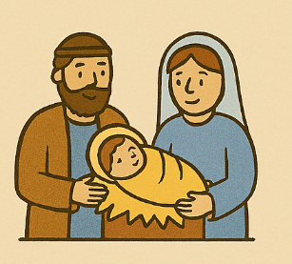  Important Ideas  The Nativity Story- Christians believe that Jesus was born in Bethlehem. His mother was Mary, and Joseph cared for them. Christians believe Jesus’ birth was special because he is God’s son.  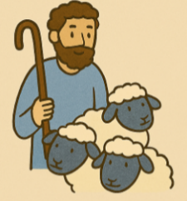  Incarnation - This means “God becoming human”. Christians believe that at Christmas, God came to Earth as Jesus.  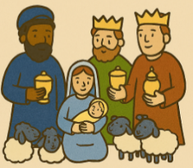  Shepherds - Shepherds were the first to hear about Jesus’ birth. This is important because they were ordinary people. It shows Christians that Jesus came for everyone.    The Star & the Wise Men- A bright star led the Wise Men to Jesus. They brought gifts of gold, frankincense, and myrrh to show that Jesus was important.  Stable - Jesus was born in a stable because there was no room at the inn. This reminds Christians that Jesus lived a simple life. | 🗝️ Key Words  Nativity: The story of Jesus’ birth  Incarnation: God becoming human as Jesus  Stable: Where Jesus was born  Shepherds: First people to hear about Jesus’ birth  Wise Men: Visitors who brought gifts  Star: Guided the Wise Men to find Jesus   | Questions to Think About  - What parts of Christmas are linked to the Nativity story?  - Are there parts of Christmas today that are not connected to Christianity?  - What do you think Christmas means to Christians?  - What is important to you at Christmas time?
Home learning ideas/questions:
What do we feel about Christmas? How would we feel about important people such as our royalty if they had been born under similar conditions to Jesus? Does it matter that he had such a poor beginning, or do we think that it is what Christians believe now that matters?

