Jigsaw RE Knowledge Organiser
Religion /Worldview: Christianity | Enquiry Question: What is good about Good Friday? | Age: 7-8 Spring 2
We are going to learn about the events of Holy Week, including Jesus’ death on Good Friday and his resurrection on Easter Sunday. We will explore why Christians believe these events are important and why Good Friday is seen as “good”.

🟩 Important Ideas    Holy Week- Holy Week is the week leading up to Easter. It begins with Palm Sunday and ends with Easter Sunday.    Maundy Thursday & The Last Supper- The night before Good Friday, Jesus shared a special meal with his friends. Christians remember this meal today with communion.  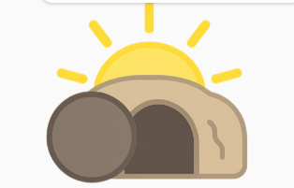  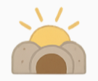  Good Friday- Christians remember the day Jesus died on the cross. They believe Jesus chose to do this because he trusted God and wanted to help people.    Resurrection- Christians believe Jesus came back to life on Easter Sunday. They see this as a sign of hope, forgiveness, and new beginnings.  Salvation - Christians believe Jesus’ death and resurrection made a way for people to be close to God forever. | 🟨 Key Words  Holy Week: The week before Easter.  Good Friday: The day Christians remember Jesus’ death.  Resurrection: Coming back to life after dying.  Crucifixion: Being put to death on a cross.  Communion: A special Christian meal of bread and wine that remembers the Last Supper.  Disciples: Jesus’ special friends.  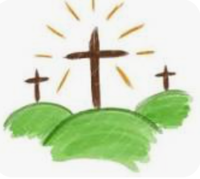 | 🟪 Questions to Think About  - Why do Christians think Good Friday is “good”?  - How might Jesus’ friends have felt during Holy Week?  - Why is Easter Sunday important to Christians?  - What does the word hope mean to you?
Home learning ideas/questions:
Do my family know about the Christian belief commemorated at Easter? What do we do to celebrate Easter, if anything?

© Jigsaw Education Group

