
Jigsaw RE Knowledge Organiser
Religion /Worldview: Christianity | Enquiry Question: Could Jesus heal people? Did he perform miracles or is there some other explanation? | Age: 7/8 Spring 1
We investigate three miracles of Jesus where healing took place. Then we evaluate if we think they were miracles or if there could be another explanation.

  Important Ideas  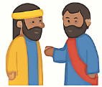  Miracles- Christians believe that Jesus performed miracles to help people. A miracle is something amazing that cannot be easily explained.  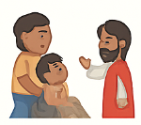  Healing the Blind Man- Jesus healed a man who had been blind since birth. Christians believe this showed Jesus’ kindness and power.  The Paralysed Man- Jesus healed a man who could not walk. His friends brought him to Jesus because they believed Jesus could help.  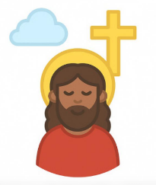    Leprosy and Illness- Jesus helped people who were unwell or treated as outcasts. Christians believe this shows Jesus cares for everyone.  Incarnation- This means God becoming human as Jesus. Christians believe this is why Jesus could perform miracles. | 🟨 Key Words  Miracle: Something amazing that cannot be explained by normal means.  Disciple: One of Jesus’ special friends or followers.  Healing: Making someone well again.  Faith: Believing and trusting in someone or something.  Paralysed: Unable to move parts of the body.  Leprosy: An illness that made people unwell and often left out by society. | 🟪 Questions to Think About  - Do you think the healing stories were miracles? Why or why not?  - How might Christians feel about Jesus’ miracles today?  - Why do you think Jesus helped people who were ill or treated badly?  - If you had been there, what would you have thought?
Home learning ideas/questions: What do we feel about miracles? Can they be explained in any other way? Do we think they ever happen today?

