Jigsaw RE Knowledge Organiser
Religion /Worldview: Judaism | Enquiry Question: What is the best way for a Jew to lead a good life? | Age: 7-9 Enquiry 1
In this unit, we look at different actions Jews take to show their trust in God.
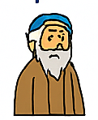  Important Ideas  Abraham  Abraham is an important person in Judaism.  He made a special promise with God, called a covenant.  God promised to look after Abraham’s family.  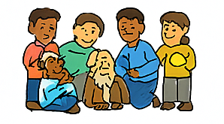    Jewish Marriage  A Jewish wedding is a special ceremony.  It shows two people making a promise to love and care for each other.  It is an important way of showing commitment.  Mitzvoth (Good Deeds)  Mitzvoth means doing good things and helping others.  There are many ways Jewish people try to be kind and helpful.  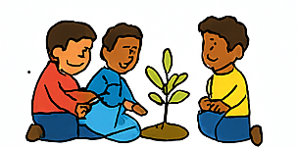  Tikkun Olam (Repairing the World)  This means trying to make the world better.  People do kind actions that help others or help the environment.  Tu B’Shevat (New Year for Trees)  A special day for thinking about trees and nature. | Key Words  - Mitzvoth: Good deeds; helping others  - Tikkun Olam: Making the world better  - Tu B’Shevat: A special day for thinking about trees and nature  Mitzvah Day: A day for doing good deeds and helping others  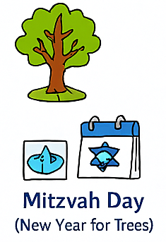 | Questions to Think About  - What special ceremonies have you taken part in?  - How do you show commitment or help others?  - What have you done at home or school to help the environment?  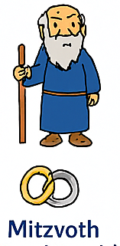
Home learning ideas/questions: What have we been to or been involved in to protect the environment or help other people?

