Jigsaw RE Knowledge Organiser
Religion /Worldview: Judaism | Enquiry Question: Does celebrating Shavuot make Jewish children feel closer to God? | Age: 7-9 Enquiry 3
We are going to learn about Shavuot, a Jewish festival that celebrates the giving of the Torah (Jewish holy teachings) to Moses. We will explore how Jewish families celebrate Shavuot today and how these traditions help them feel close to God and their history.

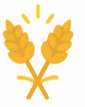  🟩 Important Ideas  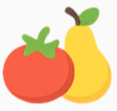  Shavuot- Shavuot means “weeks” and is also called the Feast of Weeks.  It remembers when Jews believe God gave Moses the Ten Commandments on Mount Sinai.  Bikkurim (First Fruits)- A long time ago, Jewish people brought their first wheat and fruits to the Temple in a special basket. This was their way of thanking God.  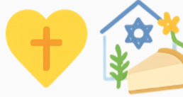    Tikkun Leil Shavuot- Some Jewish people stay awake all night to study the Torah. This tradition shows their excitement and readiness to learn from God.  The Shema-The Shema is a very important Jewish prayer that reminds Jews to love God fully. It is often read during Shavuot.  Celebrating in the Synagogue and at Home- During Shavuot, synagogues are decorated with flowers and greenery to remember Mount Sinai.  People may wear white and eat dairy foods, such as cheesecake or milk-based dishes. | 🟨 Key Words  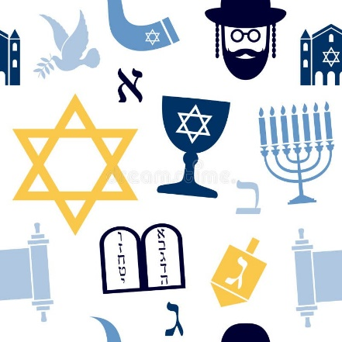  Shavuot: Festival celebrating the giving of the Torah.  Torah: Jewish holy teachings.  Bikkurim: Offering the first fruits as thanks to God.  Shema: A very important Jewish prayer.  Mezuzah: Small scroll in a case on a Jewish doorway, containing part of the Shema.  Tefillin: Small boxes worn by some Jewish people for prayer, containing words from the Torah. | 🟪 Questions to Think About  - Why might Jewish people want to remember the giving of the Torah?  - How do celebrations help people feel closer to their religion or history?  - Why do you think some people stay awake all night to study?  - What special events help you feel connected to your family or beliefs?
Home learning ideas/questions: What historical events can we share? Why is it important to remember events that happened a while ago?

