
Religious Education – World Religion – Judaism
Our Key Question: What is the best way for a Jew to show commitment to God?
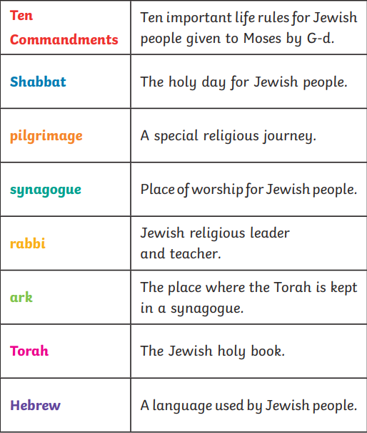
Key Vocabulary and objects for Judaism

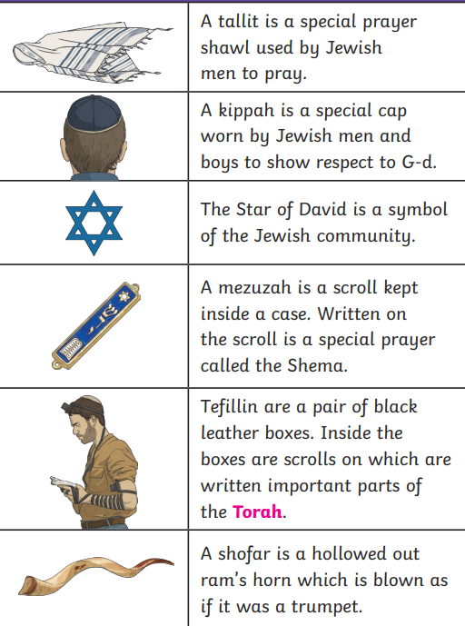

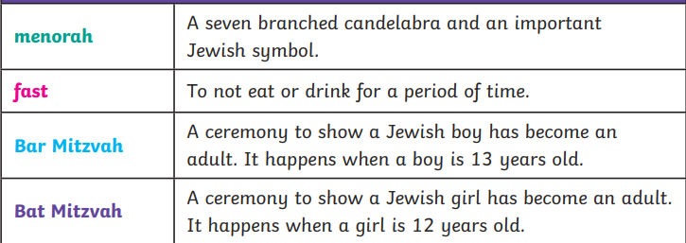

Let’s remind ourselves of the key vocabulary we have learnt previously – some words are missing for you to add:
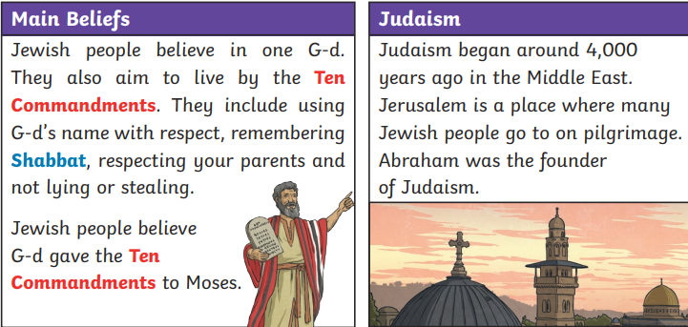

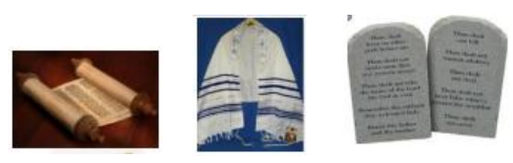

Core Knowledge:
Tenakh: Written in Hebrew and the first five books are the Torah: Genesis, Exodus, Leviticus, Numbers and Deuteronomy. This is called in Hebrew the Tenakh: Torah (Law), Nevi’im (Prophets), Ketuvim (Writings). (Sometimes the whole of the Jewish Bible is referred to as the Torah.)
Torah (first five books): Jewish belief is that the Torah was given to Moses by God. The teachings of the Torah influence all Jewish life as Jews are required to follow the 613 mitzvot (commandments or laws) which were expanded from the original 10 commandments given to Moses.
Prayer: There are three daily periods of prayer; early morning, afternoon and evening
Synagogue: The main place for community worship is the synagogue. A synagogue is the centre of the community as well as a place to meet, worship and pray
Bar/Bat Mitzvah: The Jewish initiation ceremony is called Bar or Bat Mitzvah.
Shabbat (Sabbath): Shabbat is celebrated both in the home and the synagogue and the main requirement is that no work should be attempted from sunset on Friday until sunset on Saturday.

Key Learning:
I can show an understanding of how people show commitment in their lives

l can choose a Jewish practice and describe how it enables Jews to show their commitment to God
l can describe how Bar and Bat Mitzvah enable Jews to show their commitment to God
I can describe how the different practices can enable Jews to show commitment to God and compare to similar rites of passage that I know about
I can describe how different practices enable Jews to show their commitment to God and understand that some of these will be more significant to some Jews than others
I can explain how people may show different levels of commitment in public, although their beliefs might be the same

