Year 2
Heatwave Home Learning
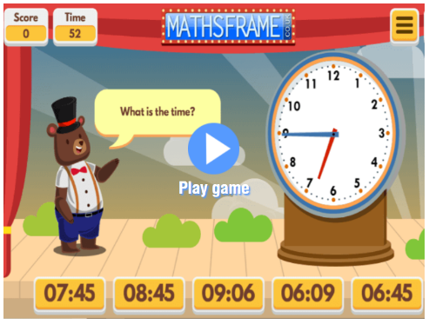
Maths:

Pick a level that your child is comfortable with! We have taught levels 1-4.
https://mathsframe.co.uk/en/resources/resource/116/telling-the-time

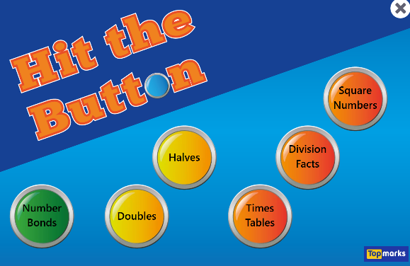
Any of these activities (except square numbers)

https://www.topmarks.co.uk/maths-games/hit-the-button
If you would prefer for your child to be off a screen and learning, then please give them a target number (under 100) and ask them to write as many addition, subtraction, multiplication and division sentences as they can for that number.
Hint for picking a target number: in Year 2 we only focus on 2x, 5x and 10x tables so I’d pick a number that is a multiple of one of these.

Who can get another certificate this week?

English:
Ask your child to write as many expanded noun phrases as they can linked to these images.
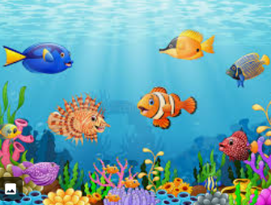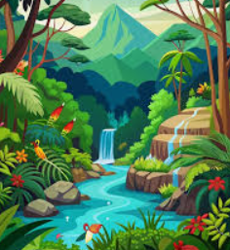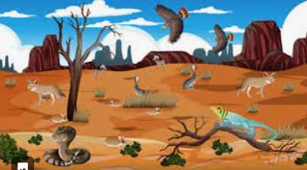
e.g.
swirling, colourful fish
bright, shimmering waterfall
dry, dusty desert
As an extension task, can they put these into sentences and imagine they are taking a walk through one of these landscapes? What would they see or hear?

Please do encourage writing neatly with a pencil in their very best joined up writing!
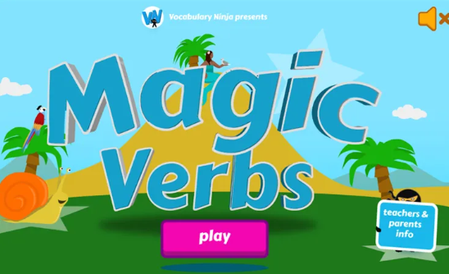
A great game for developing language when writing!
https://games.vocabularyninja.co.uk/games/MagicVerbs/

Geography
Our lesson this week was about identifying human and physical features of Jamaica and Langford.
Please do encourage your child to either use the image below, or to research images of their own from the internet, magazines, atlases etc.
Can they draw their own picture from the images and label the physical features (hill, beach, mountain etc) in one colour and human features (road, path, houses, shops etc) in another?
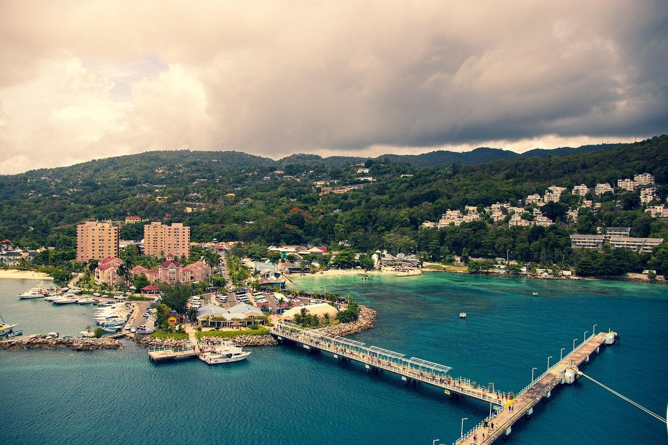
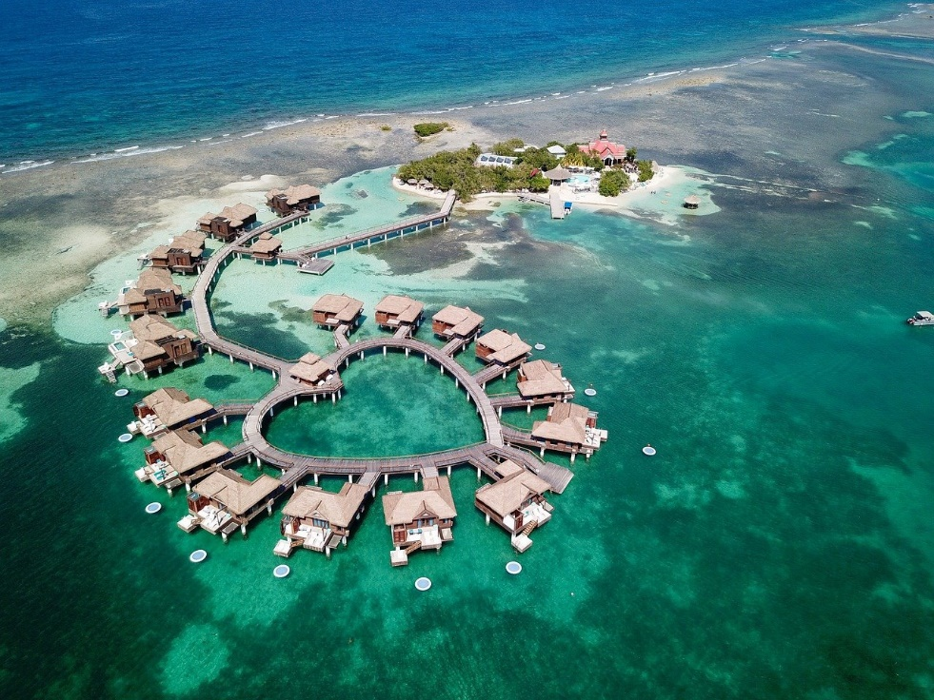
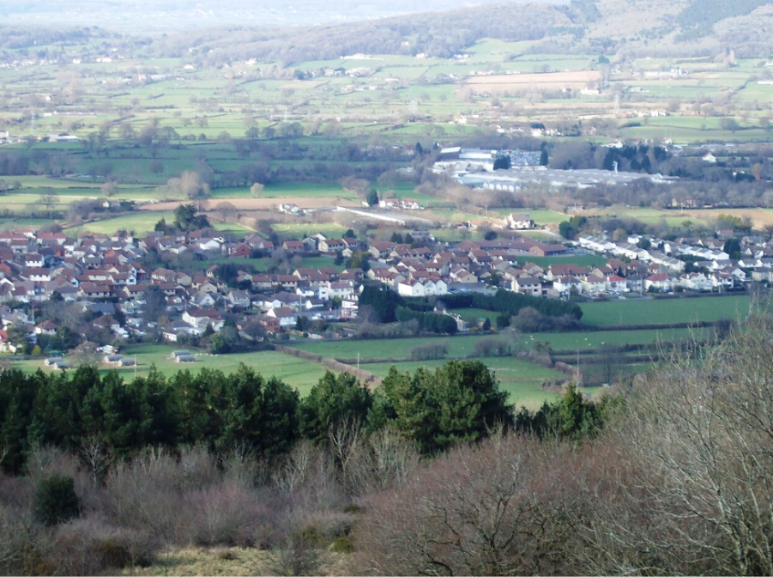

Please remember that we are not expecting all this work to be completed over these 2 days!
Just keep yourselves safe and cool!

Do bring in anything that you have completed on Friday for us to celebrate and share!

