
With Armed Forces Day coming up on Saturday 27th June follow the link to explore activities, trails, videos and quizzes to find out more about our armed forces. Alternatively, you could do your own research and create a poster sharing your learning about the army, navy and the air force.

With Armed Forces Day coming up on Saturday 27th June follow the link to find explore activities, trails, videos and quizzes to find out more about the armed forces. Alternatively, you could do your own research and create a poster sharing your learning about the army, navy and the air force.

Armed Forces Day


The Heat Is On!
Follow the link to join an online short, lively session of mathematical thinking and problem-solving between 9.00 – 9.30 am.

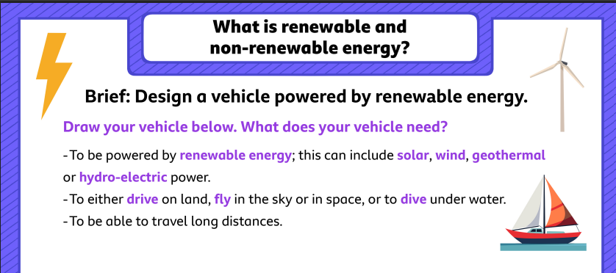
Use the link to learn more about different energy sources and then design your own vehicle powered by renewable energy.
Renewable and non-renewable energy

