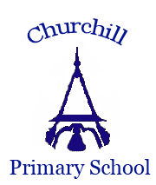
Music at Churchill CE VC Primary School
Intent, implementation and impact
‘Music is a universal language that embodies one of the highest forms of creativity’ (National Curriculum, September 2013)
Before joining Reception, children are already familiar with a variety of music, having experienced it through rhymes and games, either at home or in a preschool setting, music on television, the radio or streamed at home or in the car by their families. Music forms a core part of the daily early years teaching of sounds, words and language, for example, using familiar tunes to learn the alphabet. At Churchill, we continue our pupils’ musical experience through Key Stage 1 and Key Stage 2, building their repertoire of songs alongside learning about different types and styles of music. We ensure that all pupils are able to access a music education, as well as have opportunities to share music as a school, enjoying the feelings of joy and community that doing so can bring.
Our intent:
Here at Churchill our intention is to provide a programme of study for Music which engages and inspires our pupils to develop their own love of music and their individual talent as musicians through listening, singing, playing, evaluating, analysing and composing across a wide variety of historical periods, styles, traditions and musical genres. Through structured learning, pupils raw on their own experiences and interests to build on their existing musical knowledge as they progress through the school. We aim for our pupils to develop a curiosity for music as a subject, through an appreciation and understanding of all types of music, giving them the opportunity to explore music in a variety of settings and contexts, and embrace their inquisitive nature. We also place emphasis on being a ‘singing school’ with the aim of all pupils having experience of singing within their classrooms, the school as a whole and opportunities to sing at external events, leaving year six with the ability to sing melodies and harmonies confidently.
The National Curriculum for music aims to ensure that all pupils:
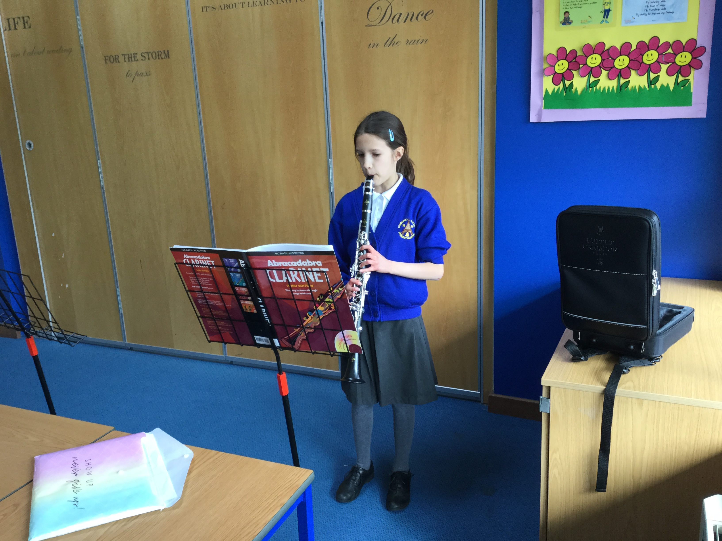
- Perform, listen to, review and evaluate music;
- Learn to sing and to use their voices, creating and composing music individually and with others (including opportunities to learn musical instruments and use technology appropriately);
- Understand and explore how music is created, produced and communicated (though exploring pitch, duration, dynamics, tempo, timbre, texture, structure and musical notation)
At the heart of our music curriculum and teaching are the core Christian values and four key attitudes for life that underpin being a part of the Churchill Primary community: to be ready, resilient, responsible and respectful. It promotes our intent across all subjects that children are safe to make mistakes and can see that these are important part of learning.

Implementation:
Using our chosen scheme of work (Charanga), our music curriculum at Churchill follows units of work which contain the strands of musical learning to correspond with the National Curriculum for music, as follows:
- Listening and appraising;
- Musical activities which include singing, playing instruments, improvisation and composition;
- Performing.
The following diagram represents how as the children progress their music learning through Key Stages 1 and 2 using the Charanga Scheme, through experiencing the interrelated dimensions of music in the form of a spiral which is ever-increasing.

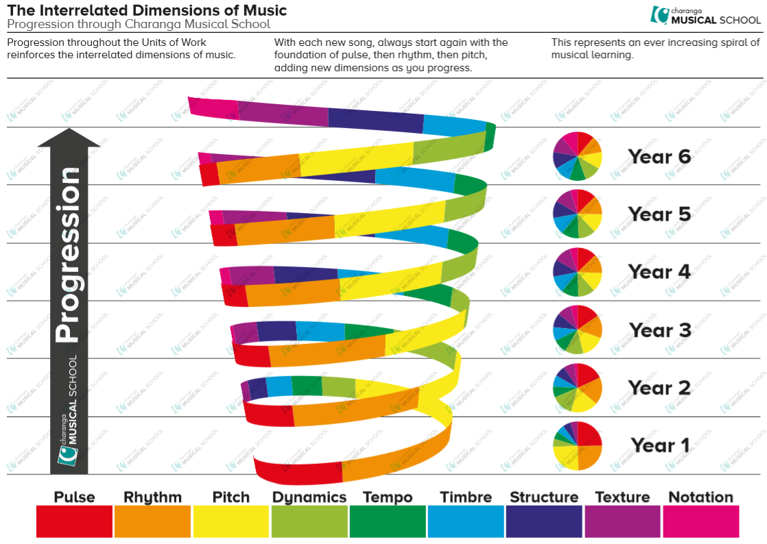

The skills learnt build year on year through exploring a wide variety of musical styles. These are linked to a timeline of musical history so children can appreciate their origins and when each style emerged, beginning to understand the musical influence that different styles have had on each other and how they are also often interrelated.

Coverage of musical styles and additional musical activity
Year Group | Autumn (Terms 1 & 2) | Spring (Terms 3 & 4) | Summer (Terms 5 & 6)
R | Early Learning Goals (in line with EYFS curriculum: Being imaginative and expressive through singing a range of well-known nursery rhymes and songs, performing them with others and moving in time to music. Involvement in Key Stage 1 Nativity.
1 | Styles: Hip Hop and Reggae  Additional musical activity: Key Stage 1 Nativity | Styles: Blues, Baroque, Latin, Bhangra, Folk, Funk music  Additional musical activity: School music festival | Styles: Classical music  Beginning to explore the history of music
2 | Styles: South African music  Additional musical activity: Key Stage 1 Nativity | Styles: Rock and Reggae  Additional musical activity: School music festival | Styles: Pop, Soul, Film, Musicals, Classical  Songs about friendship
3 | Styles: R&B, Western Classical, Musicals, Motown, Soul  Playing the glockenspiel 1  Additional musical activity: Key Stage 2 Carol Service  Violin project | Style: Reggae and World Music  Learning to improvise  Additional musical activity: School music festival  Violin project | Styles: Disco and Classical  Songs about kindness, respect, peace, hope and unity  Additional musical activity:  Violin project
4 | Style: ABBA  Playing the glockenspiel 2  Additional musical activity: Key Stage 2 Carol Service | Styles: Grime, Classical, Bhangra, Tango, Latin Fusion, Gospel  Additional musical activity: School music festival | Styles: Classical and The Beatles
5 | Styles: Rock and Jazz  Additional musical activity: Key Stage 2 Carol Service | Styles: Pop Ballads and Disco  Additional musical activity: School music festival | Styles: Motown and Classical
6 | Styles: Pop/Motown, Jazz, Latin, Blues  Additional musical activity: Key Stage 2 Carol Service | Styles: Classical, Gospel, Bhangra, Music of Carole King  Additional musical activity: School music festival | Styles: Contemporary and Classical  Additional musical activity: End of Year 6 Production (musical)

This is embedded within the lessons that take place in classrooms weekly (lessons between 45 minutes and 1 hour), as well as weekly ‘Big Sings’ (where the whole school come together to learn new songs), individual and group instrumental tuition (delivered by specialist visiting tutors), opportunities to join the school choir in KS2, participation in external cluster concerts and celebrations, and annual school concerts and performances. We encourage pupils to share their enjoyment of singing or playing an instrument by performing in front of the school or their classes when we meet for weekly services.
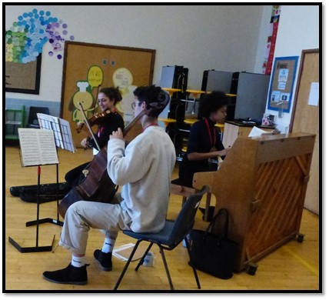
We also welcome visiting ensembles and individual musicians when possible to share their passion for music with the children and inspire them to explore their musical journey further.
The scheme we use enables children to understand musical concepts through a repetition-based approach to learning, to enable a more secure, deeper learning and mastery of musical skills. To complement our scheme, we have strong links with Churchill Music who promote making world class music accessible to school pupils through facilitating visiting musicians, concerts, composition projects and lessons on individual instruments. Previously we have been able to offer pupils clarinet lessons and violin lessons facilitated and subsidised by Churchill Music.
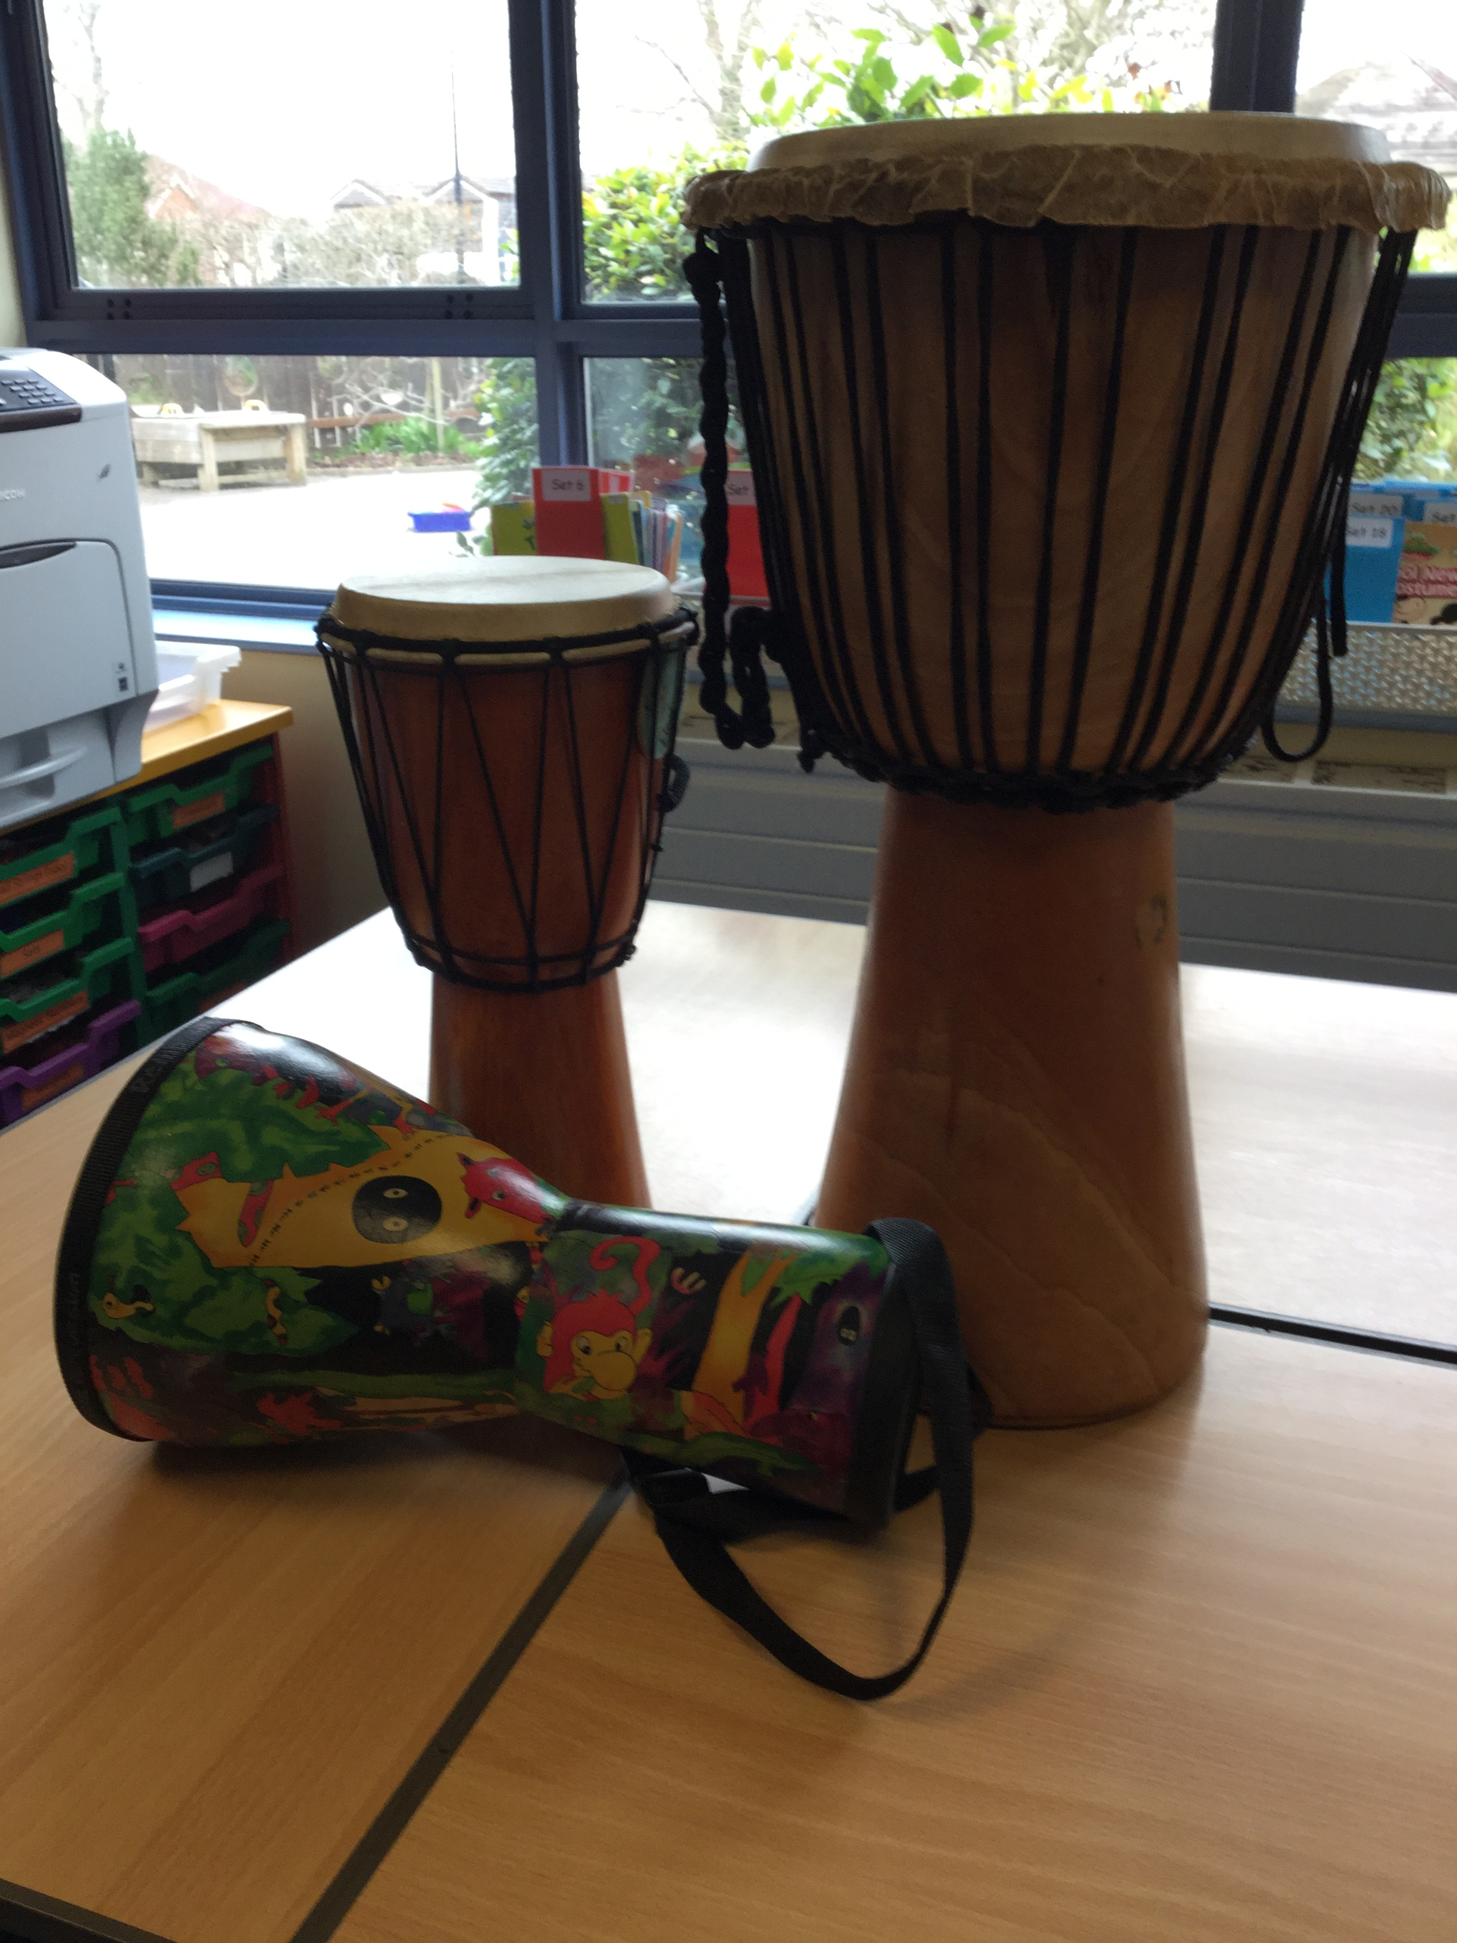
We are currently involved in a project where every Year 3 pupil will have the opportunity to learn the violin, again which is jointly funded by Churchill Music and the school. They receive 10 lessons with a qualified violin teacher building towards a final performance to their peers and parents.
We offer pupils in Upper Key Stage 2 the experience of the ‘Power of Music’ project run by Churchill Music. It helps pupils to manage difficult feelings and change or encourage a different mood through music and links to the 2020 Department of Education Mental Health Awareness curriculum. It aims to demonstrate positively how music can effect how pupils feel and their wellbeing and is delivered by professional musicians from Churchill Music. Linked to this, we can facilitate in organising the delivery of individual music therapy sessions for any pupils who would benefit from exploring these connections between music and wellbeing further.
A recent refurbishment of our music room has meant that we are able to offer a fully accessible space for visiting teachers to tutor individual pupils on a variety of instruments, alongside a resource base that can inspire our staff to use a wider variety of instruments within their music lessons. It can also be a space where our pupils can spend time exploring instruments in a safe and welcoming space, to help them be creative and have the opportunity to play instruments freely – something which many of our pupils find helps them to relieve anxiety or self-regulate.
Impact:
Allowing our pupils to discover their own areas of strength within music, as well as identifying areas they may wish to improve upon, is achieved through the access that they have to a varied programme of study. As we develop our practice further, we plan to introduce an assessment framework that will incorporate a ‘plan-do-check-review’ approach through our scheme of work. Alongside the classroom learning, we encourage our pupils to explore a wider world of music through additional experiences, as mentioned above. Opportunities within classroom topics for additional performance or composition opportunities often arise, including sharing performances with parents in our class T@3 events and Christmas celebrations, often held both within school or at our link church, St Mary’s.
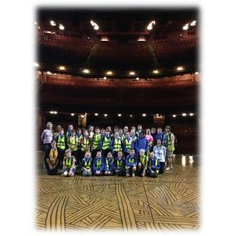
We also aim to encourage an understanding of culture and history, including exploring music from across the world. We want our pupils to enjoy music in as many ways as they would like or choose to as listeners, composers or performers, inspiring them to explore how they can progress their own individual musical experience further as they move through their educational years. We hope to see that through music, pupils are able to increase their self-confidence, creativity and sense of achievement.
We encourage links with local schools and music projects such as Churchill Music, to help with the transition between primary and secondary school and encourage pupils to continue their musical journey as they move on from Churchill Primary.

