
History Knowledge Organiser Year 3
Stone Age to Iron Age
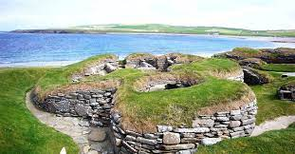
Our Key Question: Would you rather live in the Stone Age or the Iron Age?
Key Vocabulary
prehistory | the time before people started writing and being able to record events. | Iron Age | Period of time (700BC – 43AD) when people used mostly iron tools.
Stone Age | Period of time (800,000BC – 2400BC) when people alive used mostly stone tools. Stone Age divided into Palaeolithic, Mesolithic and Neolithic. | Neanderthal | A species of very early human. There is evidence of Neanderthal humans living in Britain from around 60,000 BC.
Paleolithic | Paleolithic comes from the Greek for old stone. It is the first period of the Stone Age from 800,000BC – 10,500BC. | hunter-gatherer | A human living in a society in which most or all food is obtained by foraging (collecting wild plants and pursuing wild animals).
Mesolithic | Mesolithic comes from the Greek for middle stone. It is the second period of the Stone Age from 10,500BC – 4000BC. | Celts | Iron age people in Britain were called the Celts and we use the adjective Celtic to describe the things they made.
Neolithic | Neolithic comes from the Greek for new stone. It is the last period of the Stone Age from 4000BC – 2400BC. | druid | A Celtic priest-like figure who trained for several years, learning how to conduct rituals correctly, and how to prepare medicines from herbs.
Bronze Age | Period of time (2400BC – 700BC) when people mostly used bronze tools. | Boudicca | A ruler of the Iceni people, provoked by Roman seizure of land and the brutal treatment of her family, raised an army to fight the Romans.
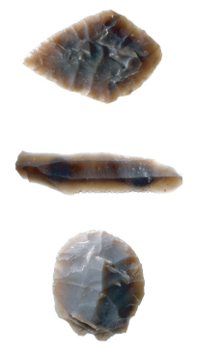
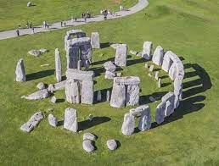
Stonehenge Skara Brae

Stone tools

