


Year 2 Homework Expectations
The reason for Homework
Homework is given to reinforce aspects of learning relevant to that which has been undertaken in class. Homework should not present your child with a new concept but enables you so see what your child has been learning so you can support them in applying and developing this knowledge. Should your child run out of time or not understand the homework set, please pop in and speak to the class teacher or let us know by writing in the reading record.

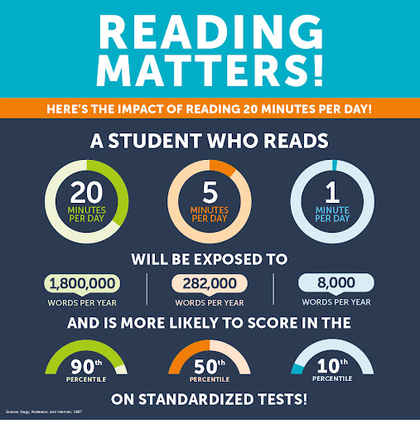

Reading
We do expect all children to read at least 5 times each week.
Each child is given a reading record, and we would ask that all reading done at home be entered into the reading record along with the date and signature of the adult who has supervised this. We do encourage reading a wide range of genres, so it is perfectly acceptable to record any reading from appropriate home/library books or publications, in addition to the school’s book schemes. House points will be awarded for each time your child has read with an adult at home.
Reading records are checked every morning and, if appropriate, children will be able to change their books.
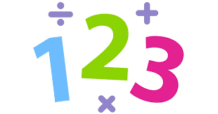
Maths
Children are expected to regularly use Numbots at home to practise their number facts and number bonds.
Certificates are awarded for completing levels in Numbots in Celebration Service each week.

