Is the Christmas story true?
Key Information  - The Bible records the important events in the life of Jesus in the Gospels.  - The Gospels were probably not written as events happened. They would have been told and retold before recording, therefore specific dates and times may have become unknown (or irrelevant)  - The fixing of a festival date to commemorate an event does not necessarily have to happen on the actual date of the event  - The Gospels which retell the birth of Jesus agree on the main points and disagree on nothing.
  Key terms and definitions
  Christian | A follower of the religion of Christianity
  Gospels | Literally means ‘good news’
  Gospel writers | Matthew, Mark, Luke and John – four of Jesus’ disciples.
  Disciples | Jesus’ special friends
  Truth | Historical Fact
   | Scientific truth
   | Personal truth: an individual’s deeply held belief shaped by their values, beliefs, emotions and experiences that guides their decisions in life.
  Incarnation | Means ‘made flesh’.  The Christian belief that God became a man in the person of Jesus, fully human and fully God.
History
There are some factors within the story which are less likely to point to December being the month in which Jesus was actually born. For example, the sheep being out in the fields, suggest the weather would have been warmer, so he may have been born in the spring.
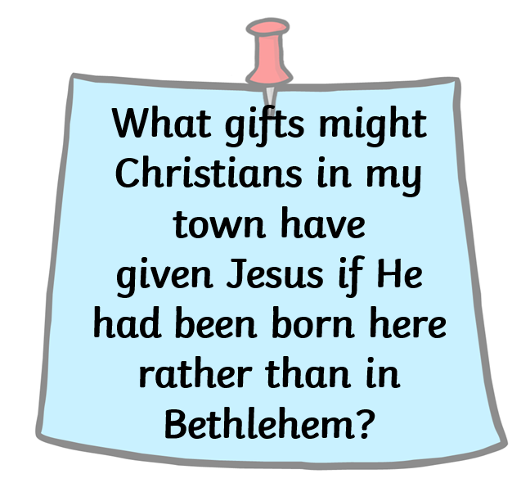

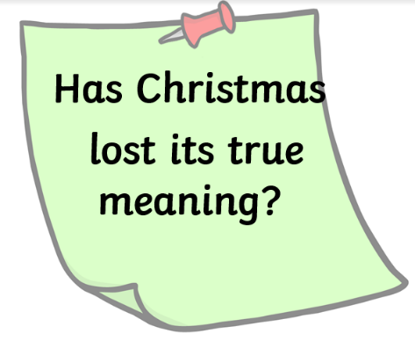
Previous questions studied:

